
KEB HART BIO - AUGUST 2024
KEB HART is a guitarist and singer/ songwriter. His musical styles encompass anything guitar-based such as Blues, Americana, Alt-Folk, Reggae and Rock.
He was born in Coventry, England but now lives and writes in Cambridge, New Zealand.
His memorable tunes reflect his life experiences; he writes about failed relationships, finding new ones and paying the bills! He believes in good lyrical content and is very particular about the music production.
His focus in 2025 is the release of his album “Once I Was”. An 8-track album released in 2 parts with an eclectic mix of genres to keep everyone on their toes! Look out for the videos with the singles too.
Instagram: @kebhartmusic
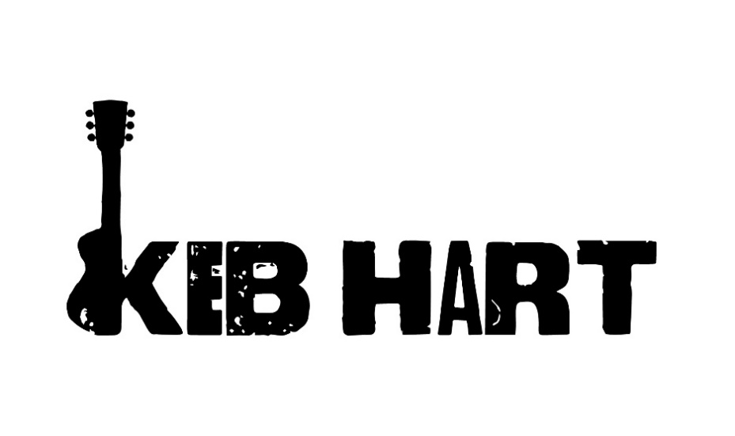
Email: kebhartmusic@gmail.com
Phone: +64 (0)21 246 6979



